**Using Git as a Team**

Git is a really powerful tool but it can also be an issue when many people are working on the same project. It is possible to completely override all of the code in the project and have to start over from scratch. I have a few suggestions to avoid catastrophe and streamline the process.

We will be using Forking mostly to complete our projects. When you fork the project files it allows you to have the entire project at your fingertips not just a few files. Once you have the Fork (access at this link <https://github.com/RobDog04/eecs448-project1>). You can then clone it locally to your device of choice. All of this was in the labs but I(Rob) am more than happy to help you troubleshoot, feel free to message me anytime on discord in the Git-help channel.

Once you begin working, try to let others know what you are trying to tackle via discord so two people aren't working on something simultaneously. As you start, run a ‘git pull’ command just to make sure you are up to date from the main files. As you finish working and want to submit your files, run another ‘git pull’ then a ‘git commit’. This should update *your* files.

When you are done working for the day or need to submit something for someone else to access, go back to your repository and look for this icon on the homepage of your fork of the project,

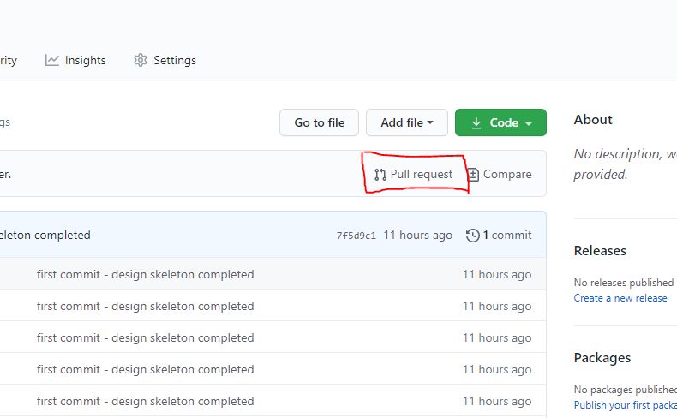

When you hit that it will alert me and I can accept the pull and double check to see what has been changed. Write a brief description of what was done so it's easier to see if there were any issues.

I will be backing the files up every night to ensure at worst all we could lose is a day's work. I doubt this will happen but at least there will be some sense of security for us.

**This is all subject to change if we would like to move in a different direction or if I need to make things more clear/add things.**